

**Assignment no 1**

|  |  |
| --- | --- |
| **Name** | **Ijlal Hussain** |
| **Class** | **SE-7B** |
| **Reg no** | **FA18-BSE-083** |
| **Submitted to** | **Sir Kamran** |

**Relative layout**

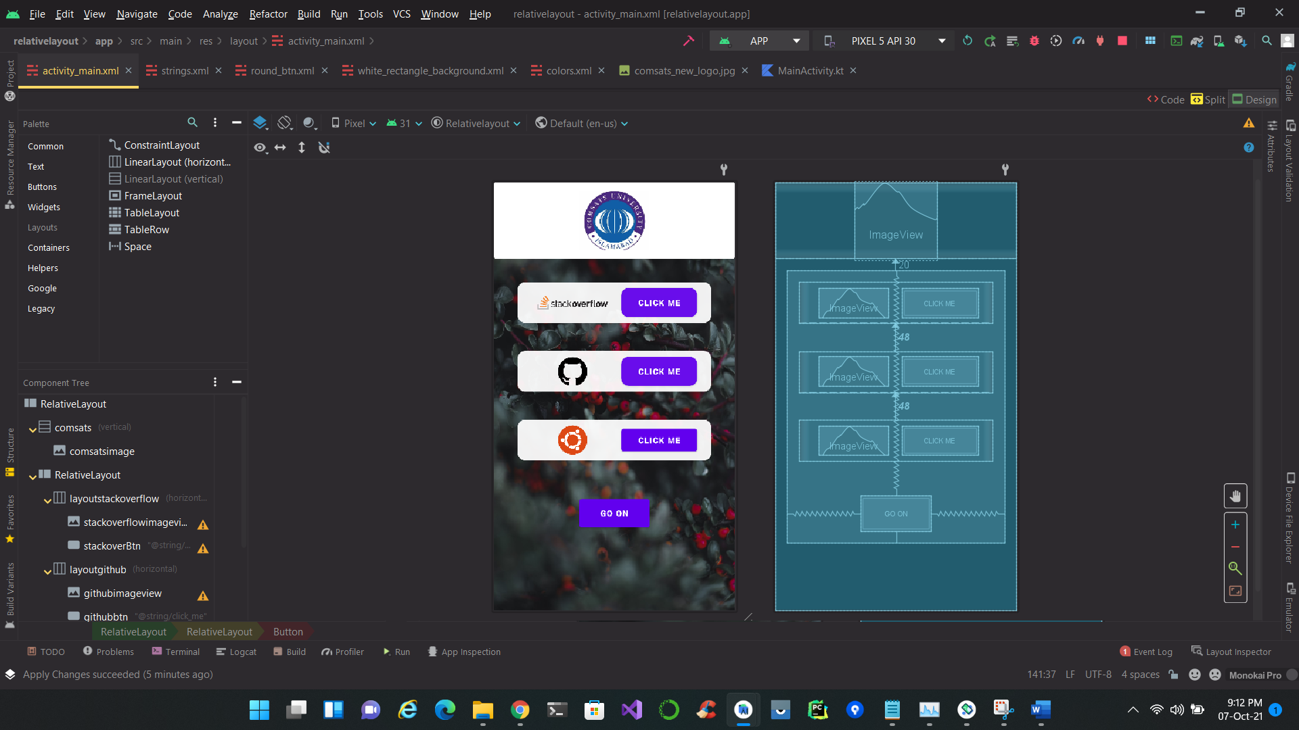

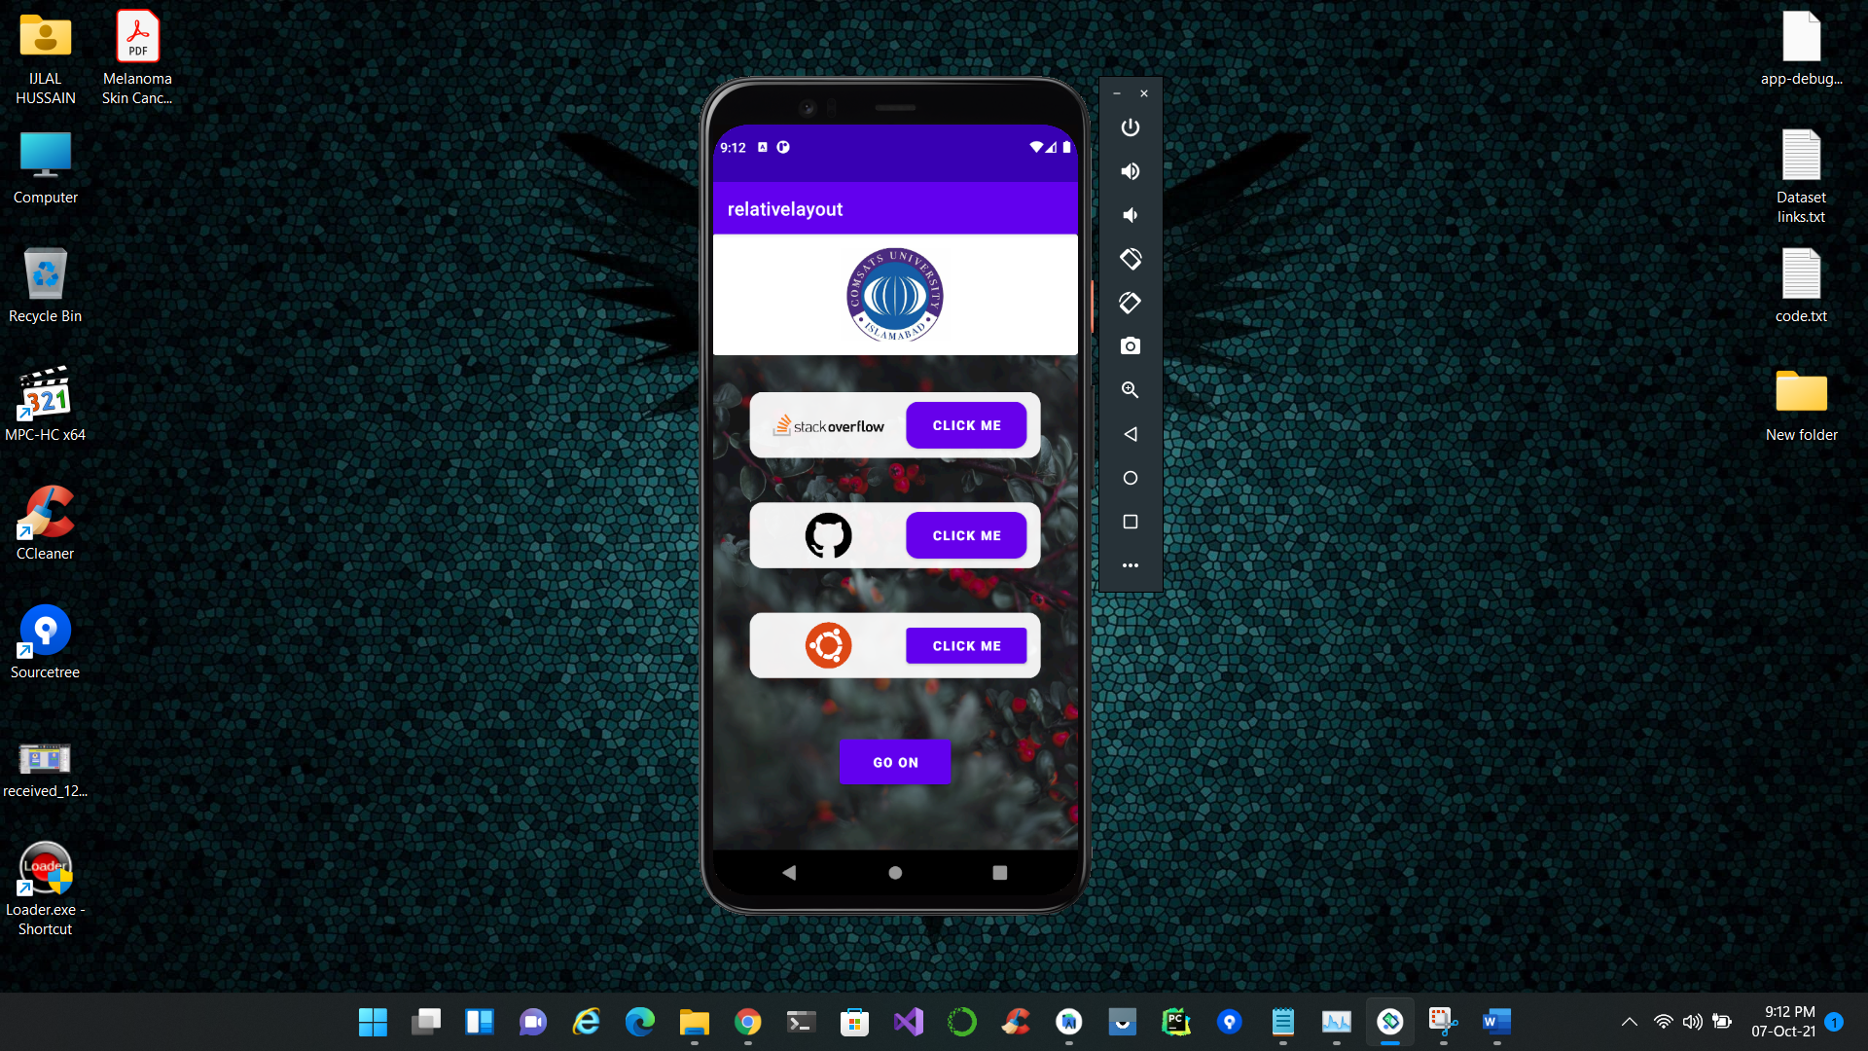

**Constraint layout**

